UID EX 6
RAD (Rapid Application Development) is a software development methodology that emphasizes quick development and iteration of prototypes over strict planning and long development cycles. It is ideal for projects where requirements evolve through user feedback and where fast delivery is important.

Key Characteristics of RAD:
- Focus on prototypes instead of extensive documentation
- User involvement throughout the development process
- Fast development cycles with frequent iterations
- Reusable components to reduce effort
- Best suited for UI/UX-intensive projects like web and mobile apps

Phase 1: Requirements Planning
This is where the project goals, system requirements, and user needs are identified. Stakeholders, users, and designers collaborate to decide what needs to be built.

Identify Key Features
Navigation:
  - Login / Sign Up
  - Home (Restaurants Near You)
  - Restaurant Menu
  - Cart
  - Delivery Address
  - Choose Delivery Option
  - Order Tracking
  - Proof of Delivery
User Actions: Browsing, Searching, Adding to Cart, Checkout, Tracking Orders, Confirming Delivery

Create a Requirements Document:
- Login or Sign Up to access the app
- View list of restaurants near the user with ratings and distance
- Browse menu items under each restaurant with prices and Add to Cart option
- View and manage cart with order summary and total price
- Enter delivery address with street, city, ZIP, phone, and special instructions
- Choose delivery option: Standard, Express, or Scheduled
- Track order status in real time with driver details
- Confirm delivery with signature and optional photo

Phase 2: User Design

Designers and users collaborate to create wireframes and prototypes. The idea is to show how the application will look and behave before any actual coding starts.
- Tools Used: Axure RP — Used to design the wireframes and UI prototype.

Wireframes Designed:
  - Login Screen: Email and password fields with Login and Sign Up buttons.
  - Home Screen: Lists nearby restaurants with ratings, delivery time, and distance.
  - Menu Screen: Shows food items with name, price, category tag, and Add to Cart button.
  - Cart Screen: Displays selected items with quantity, price breakdown, and Proceed to Checkout.
  - Delivery Address Screen: Form for street, city, ZIP, phone, and delivery instructions.
  - Choose Delivery Option Screen: Standard, Express, or Scheduled delivery with cost and time.
  - Order Tracking Screen: Real-time status (Order Placed, Preparing, Out for Delivery, Delivered) and driver info.
  - Proof of Delivery Screen: Signature pad, optional photo, and Confirm Delivery button.
Designed interactions and navigation using Axure's Prototype mode. Reused components like headers/footers using Masters. Annotated elements for clarity (e.g., what a button does, purpose of sections).
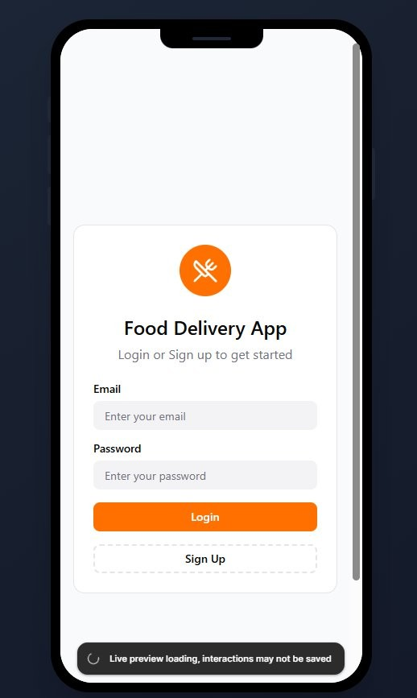
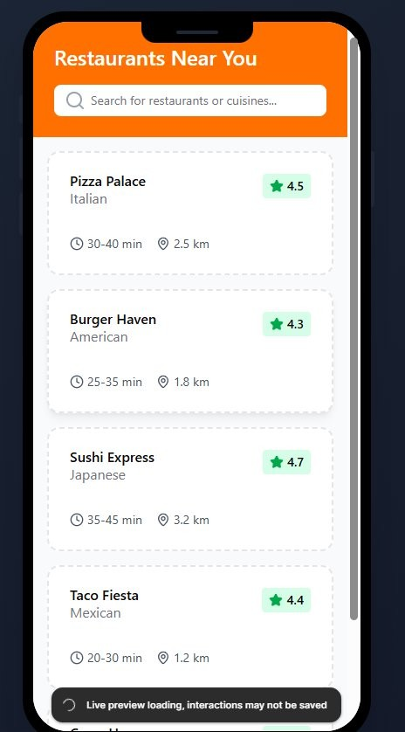
Screen 1: Login Screen Screen 2: Home – Restaurants Near You

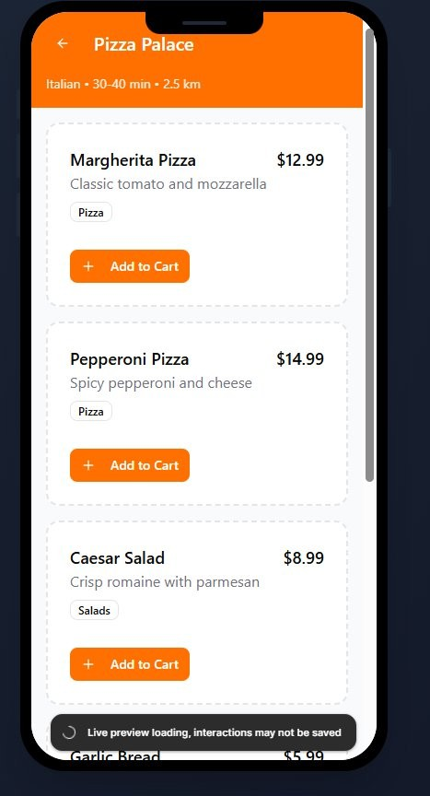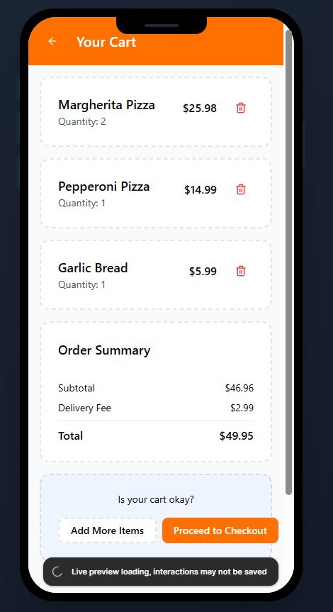

Screen 3: Menu Screen (Pizza Palace) Screen 4: Cart Screen
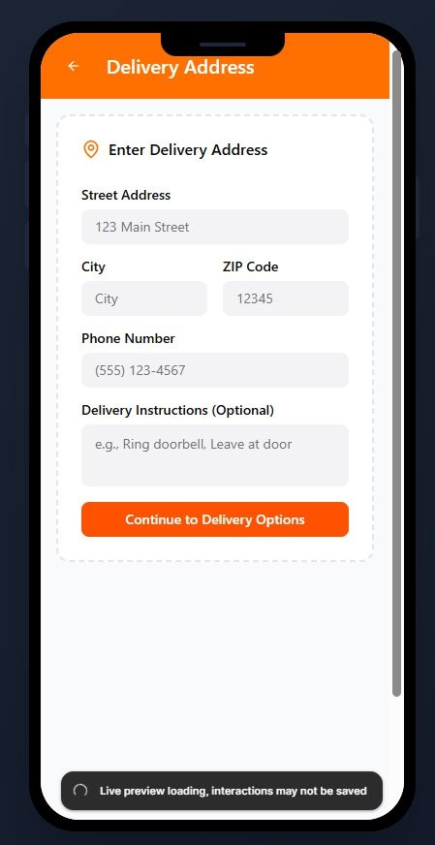
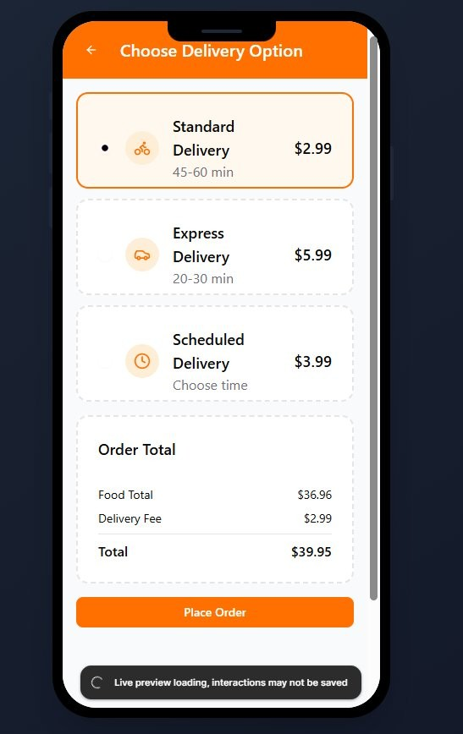
Screen 5: Delivery Address Screen 6: Choose Delivery Option

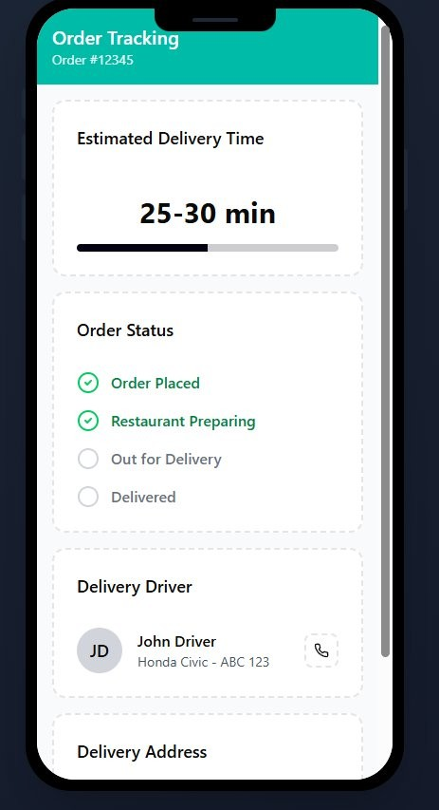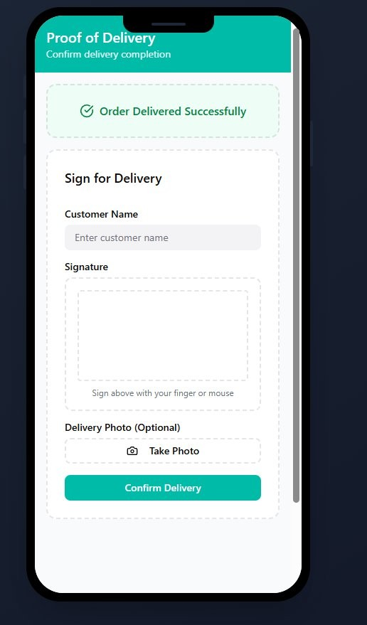

Screen 7: Order Tracking Screen 8: Proof of Delivery

Phase 3: Construction
This is where the actual development happens, but in RAD, it is tightly coupled with ongoing testing and feedback. The prototype is refined based on user responses.

Interactive Prototypes:
  - Created using Axure's prototype linking features.
  - Functional paths designed:
o Login → Home (Restaurants Near You) → Menu → Add to Cart → Cart → Delivery Address → Choose Delivery Option → Order Tracking → Proof of Delivery

Dynamic Elements:
  - Simulated transitions between screens for adding to cart and checking out.
  - Screens simulate real-time behavior such as navigating between restaurant listings and the cart.
  - Order tracking progress bar and status steps created with dynamic panels.
  - Signature pad on Proof of Delivery screen simulates interactive input.

Testing and Iteration:
  - Prototype previewed using Axure's "Present" / Live Preview mode.
  - Collected feedback from stakeholders (assumed for documentation).
  - Iterated based on visual hierarchy, accessibility, and flow suggestions.

Phase 4: Cutover
In this final phase, the system goes live. This includes finalizing the design, training users, and preparing documentation for developers.

Finalization and Export:
  - Final design prototype shared through Axure Cloud link.
  - Ready for hand-off to the development team.
  - Can be exported to HTML/CSS using Axure's built-in publish features.

User Training and Support:
  - Walkthrough of the prototype for stakeholders or development team.
  - Notes/documentation provided for developers to understand functionality and user flow.
  - Easy access to Axure comments for further collaboration and questions.

Exp 7

Aim
To evaluate different UI layout designs based on visual appeal, usability, readability, and colour preference using user feedback.

Procedure
1. Three different UI layout designs were created and shared with users.
2. Users were asked to evaluate each layout based on:
• Visual Appeal
• Usability
• Readability
• Colour Preference
3. A Google Form was used to collect structured feedback from participants.
4. Responses were analyzed to identify strengths and improvements for each layout.

Screenshots
Screenshots of Layout 1, Layout 2, and Layout 3 should be inserted here.

Google Form
Feedback Form Link:
https://docs.google.com/forms/d/e/1FAIpQLSdVxne3t8vG9njhhlSIZjawPN1em7EGEfhLm9F5kid2euihyQ/viewform?usp=publish-editor

Results
Layout 1:
• Simple layout with bold header and minimal UI.
• Needs improvement in colour contrast.
• Suggested to add button styling such as shadows or depth.
Layout 2:
• Improved hierarchy with vibrant colour palette.
• Slightly cluttered background and tight spacing.
• Recommended to increase spacing between sections.
Layout 3:
• Balanced design with good readability and spacing.
• Visually appealing and user-friendly.
• Preferred by most users.

Screen shots : 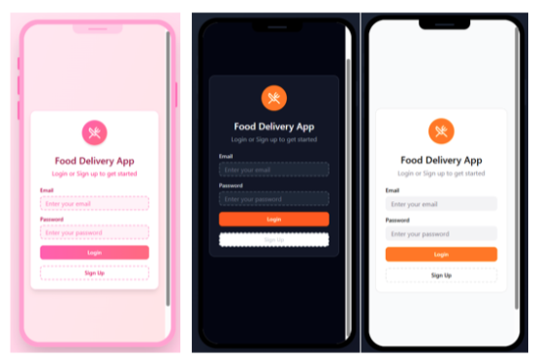

Google Form link : https://docs.google.com/forms/d/e/1FAIpQLSdVxne3t8vG9njhhlSIZjawPN1em7EGEfhLm9F5kid2euihyQ/viewform?usp=publish-editor

UID EX 8a

AIM:
The aim is to create storyboards representing the user flow for a mobile food delivery app using Balsamiq.

Procedure
- Tool Used: Balsamiq Wireframes (https://balsamiq.com)
- I created a new project and added mobile screens to simulate the user's food ordering experience from start to finish.
- Each screen represents a key step in the food browsing and purchase process.
- UI components like buttons, text fields, dropdowns, images, and icons were selected from Balsamiq's built-in library.
- All wireframes were designed to be simple, clean, and focused on user interaction and flow.

User Flow
- Home Screen – Users enter their delivery address and proceed to browse available restaurants and food items.
- Menu Screen – Displays a scrollable list of food items with name, image, short description, and price, along with an "Add to Cart" option.
- Cart Screen – Shows items added to the cart with quantities and total price, and a button to proceed to checkout.
- Checkout Screen – Users enter their delivery details (name, address, phone number) and select a payment method.
- Order Confirmation Screen – Displays a confirmation message after the order is placed successfully with estimated delivery time.

Home Screen

Components:
  - Delivery address input field
  - Restaurant/app name and star rating display
  - "Continue" button to proceed after entering address
  - Top navigation bar with Menu and Profile options
  - Bottom navigation: Home, Orders, Cart, Search

Purpose:
Starting point for the user to enter their delivery location and begin exploring the food delivery app.

Menu Screen

Components:
  - "Restaurant Menu" heading
  - Scrollable list of food items

  - Each item shows: dish name, short description, price (in Rs.), and a food image placeholder
  - Bottom navigation bar: Home, Orders, Cart, Search

Purpose:
Allows users to browse the available dishes, view descriptions and prices, and select items to add to their cart.

Cart Screen

Components:
  - List of selected items with quantity and individual price
  - Total price summary
  - "Proceed to Checkout" button
  - Option to remove or update item quantities

Purpose:
Lets users review their selected food items and total cost before proceeding to place the order.

Checkout & Payment Screen

Components:
  - Delivery Details section: Name, Address, Phone Number input fields
  - Payment Information: Mobile Payment option (Phone Pay, Google Pay, Paytm)
  - Phone number entry for UPI payment
  - Payment Scanner: QR code for scanning and paying
  - Top navigation: Menu and Profile
  - Bottom navigation: Home, Orders, Cart, Search

Purpose:
Collects the user's delivery information and payment details to finalize the food order.

Order Confirmation Screen

Components:
  - Success message confirming the order has been placed
  - Order summary with items and total cost
  - Estimated delivery time
  - "Track Order" button

Purpose:
Final confirmation step that assures the user their food order has been placed successfully and provides delivery details.

Wireframe Screenshots (Balsamiq Output):

